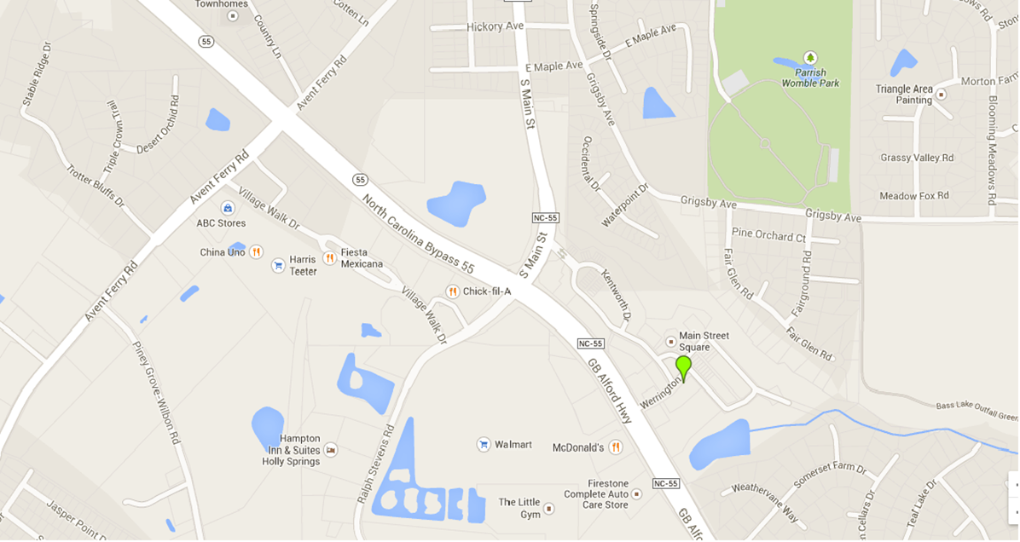

If on 55 North, you will pass Somerset Farm Dr on the right. The next road on the right is Werrington Dr. At the intersection of Werrignton Dr and Hwy 55, there is a Dunkin’ Donuts. Turn right onto Werrington Dr. We are at the intersection of Werrington and Hayes.

If you pass the Dunkin’Donuts, in 0.2 miles, there is a Capital Bank on your right and Fidelity Bank on the left. (On the right, the road is named Main St, on the left, the road is named Ralph Stevens Rd) Turn RIGHT onto Main St. Take an immediate RIGHT onto Delmare. There are townhomes in this area. At the stop sign, turn right onto Kentworth. Kentworth is a loop but also extends to a T intersection with Werrington Dr. Turn LEFT onto Werrington. We are at the stop sign of the intersection of Werrington and Hayes.

South Park Village

Dunkin’ Donuts

Fidelity Bank

Rex Health Express

Shoppes at Holly Springs

2120 Werrington Dr

Holly Springs,NC 27540

(919)-973-5620

Capital Bank