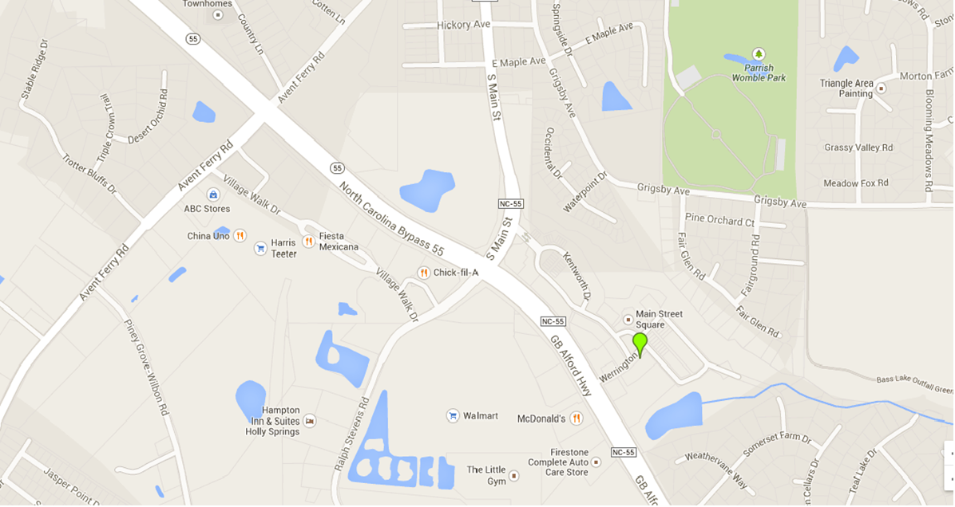

South Park Village

Dunkin’ Donuts

Fidelity Bank

Rex Health Express

Shoppes at Holly Springs

2120 Werrington Dr

Holly Springs,NC 27540

(919)-973-5620

If on 55 South, when you pass Avent Ferry Rd, on the LEFT, there is a Rex Health Care Express and on the RIGHT, there is a sign for South Park Village with a Harris Teeter listed on the sign. Continue through this intersection.

In 0.2 miles, there is a Capital Bank on your left and Fidelity Bank on the right. (On the left, the road is named Main St, on the right, the road is named Ralph Stevens Rd) Turn LEFT onto Main St. Take an immediate RIGHT onto Delmare. There are townhomes in this area. At the stop sign, turn right onto Kentworth. Kentworth is a loop but also extends to a T intersection with Werrington Dr. Turn LEFT onto Werrington. We are at the stop sign of the intersection of Werrington and Hayes.

IF YOU DO NOT TURN AT THE CAPITAL BANK onto Main St, Continue another 0.2 miles. There will be a sign on the RIGHT for the Shoppes at Holly Springs with a Wal Mart. There is a sign on the left for Main Street Square with a Dunkin’ Donuts on the corner. Turn LEFT onto Werrington Dr. We are at the stop sign at the intersection of Werrington and Hayes.

Capital Bank